A FRAMEWORK FOR PASTORAL MINISTRY

The Pastor’s Triangle

A pastor is pulled in three directions at once. The triangle is a way to see those three pulls clearly, to name what each one asks, and to keep any one of them from quietly swallowing the others.
Most clergy burnout is not a failure of effort. It is the result of one corner of the work expanding until it crowds out the rest. The Pastor’s Triangle gives language for the whole role so a pastor, a staff-parish committee, or a search team can talk honestly about where the time is actually going and where it ought to go.
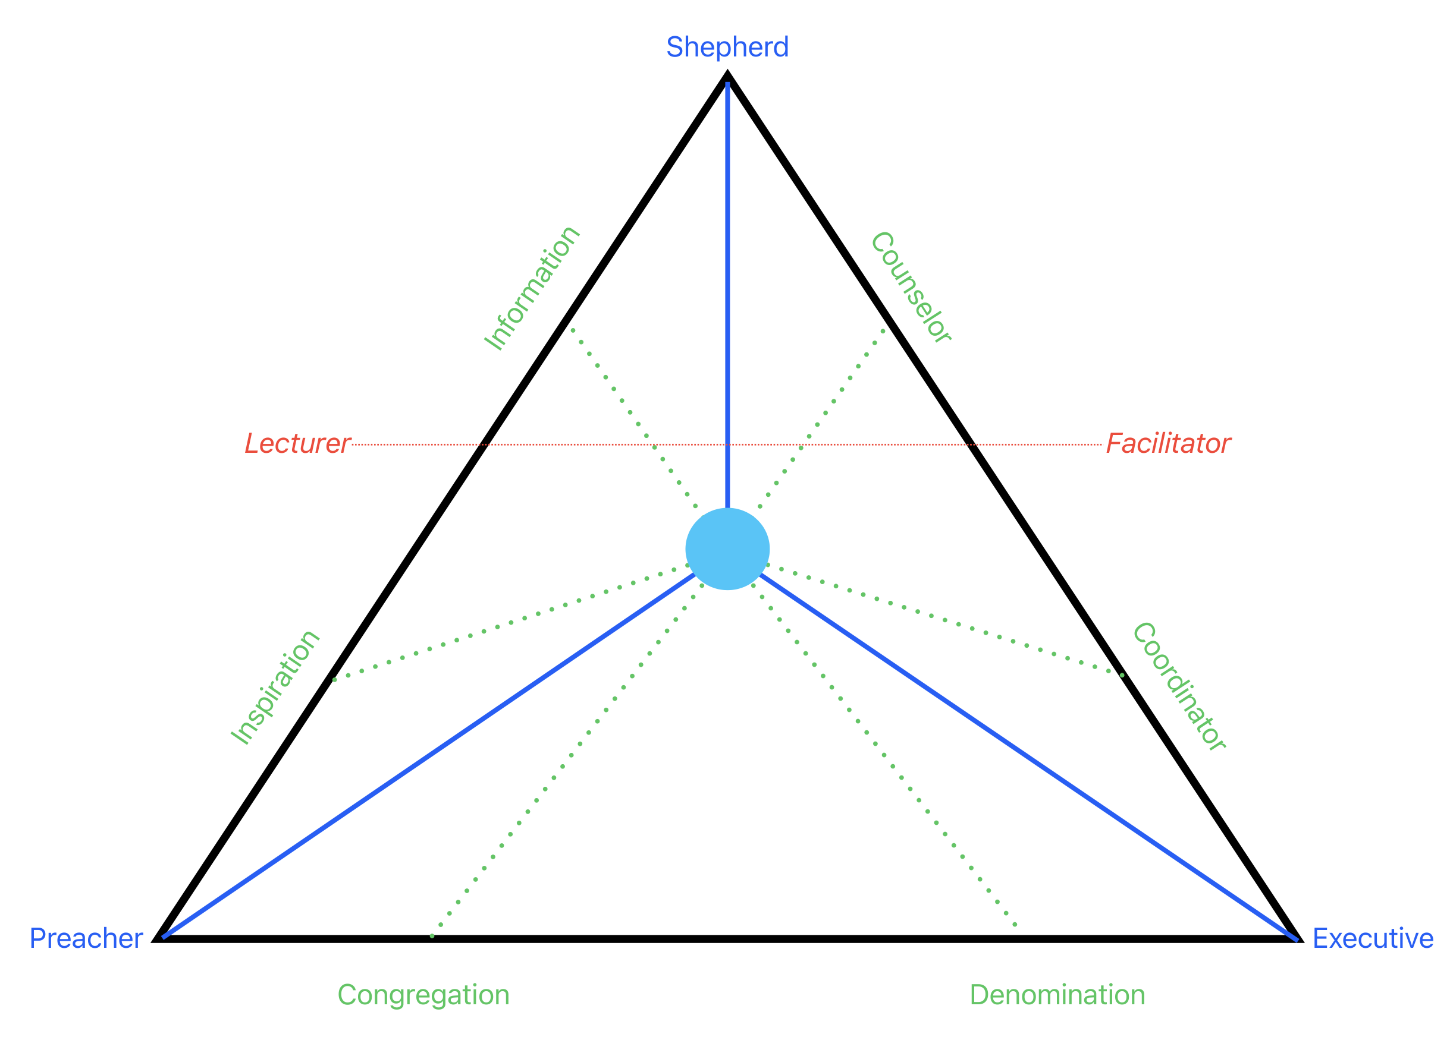
The Pastor’s Triangle, reproduced from Pastoral Ministry: Systems, Processes, and Resources (2024)

The three corners
The work of an ordained pastor sits inside a triangle with three corners. Each corner is a distinct mode of ministry, with its own audience, its own rhythm, and its own way of going wrong when it is neglected or overdone.

Shepherd
The Shepherd cares for people one at a time. This is presence: hospital and homebound visitation, one-on-one meetings, phone calls and letters, pre-marital counseling, and the holy moments of weddings, funerals, and baptisms. The Shepherd’s orientation is toward the congregation, and its currency is counsel and information, knowing the people and being known by them. Neglected, the church feels uncared for. Overdone, the pastor is consumed by reactive crisis work and never plans, preaches, or leads.

Preacher
The Preacher proclaims. This is the pulpit and the preparation behind it: setting texts and themes, study, writing, and the weekly act of preaching itself. Preaching is more than teaching facts about the Bible and more than a motivational talk. It is meant to be a vehicle for divine inspiration that leads to life transformation, and that transformation tends to come through the habit of experiencing preaching regularly over time. The Preacher’s currency is inspiration. Neglected, worship goes thin. Overdone, the pastor becomes a performer disconnected from the people in the pews.

Executive
The Executive leads the institution. This is administration and supervision: staff, committees, budgets, buildings, and the coordination that keeps every other ministry running. The Executive’s orientation reaches toward the denomination as well as the congregation, ensuring the church’s mission aligns with its larger connection. Its currency is coordination. Neglected, the organization frays and good ministries stall for lack of support. Overdone, the pastor becomes a manager who has stopped shepherding and stopped preaching.

The teaching line
A red line crosses the diagram from Lecturer on one side to Facilitator on the other. That line is the pastor's teaching role. Pastors teach constantly, in study settings and in meetings, and the line names the two modes that teaching takes. The Lecturer delivers content: the prepared Bible study, the doctrinal class, the report a committee needs explained. The Facilitator draws the room out: the discussion that finds its own way to the text, the meeting where the leader's job is to surface what others already know. The work of teaching is oscillation, sliding back and forth along that line as the setting demands. The line intersects the rest of the ministry because teaching happens in every corner, but it is not the center of the work. It is a mode the pastor moves through while doing everything else.

The blue dot
The blue dot in the middle is the hypothetical center of pastoral identity. In a perfect world a pastor lives at the center, equally proficient in every part of the triangle, floating to whichever corner or side a situation calls for. Paul described that kind of range when he wrote that he had become all things to all people so that by all possible means he might save some.
The truth is that most pastors do not live at the center. Nearly everyone has a natural tendency to drift toward one side of the triangle and spend most of the week there. That is not a flaw as long as the pastor knows it. Self-awareness turns a natural tendency into a staffing plan: a pastor who lives near one corner needs people close by, on staff and among the laity, who can cover the spaces the pastor inhabits less. Being a good pastor means being able to reach every corner and side when the moment requires it. A pastor who lives in one area and never accesses the others will find that the deficiency limits the ministry, and left unattended it can cripple it.

Reading the whole picture
The triangle is oriented between two poles, the Congregation on one side and the Denomination on the other. The Shepherd leans toward the congregation, the Executive answers in part to the denomination, and the Preacher stands in the middle proclaiming to both. A healthy ministry moves around the whole triangle through the week rather than parking in one corner.
Shepherd | Presence and pastoral care. Audience: people, one at a time. Currency: counsel and information.
Preacher | Proclamation. Audience: the gathered congregation. Currency: inspiration.
Executive | Administration and leadership. Audience: staff, committees, the connection. Currency: coordination.
Teacher | Christian formation. At the center, running through all three corners.

How to use it
- As a self-audit. Over a typical month, which corner gets the most of you? Which gets the least? Is that the ministry this season actually needs, or just the corner that shouts loudest?
- In staff-parish conversations. The triangle gives a committee shared language to talk about a pastor’s workload without it becoming personal. Saying the Executive corner is eating everything is more useful than saying you seem busy.
- In a pastoral transition. A search or appointment conversation can use the triangle to name which corner the congregation most needs strengthened, and which gifts the incoming pastor brings.
- As a guard against burnout. When one corner has swelled for months, that is the early warning. The fix is rarely working harder; it is rebalancing the triangle.

