A FRAMEWORK FOR PASTORAL MINISTRY

The Church House

John Wesley described salvation as the doorway of a house. Take the metaphor one step further and the experience of belonging to a church is like moving through the whole house and discovering the purpose of each room.
One distinctive feature of this home is that although there is a front door designed for entrance, there are many ways a person can find their way inside. The Church House maps the ministries of a congregation onto the rooms of a home, so that a leader can see the whole house at once and notice which rooms are thriving and which have been left dark.
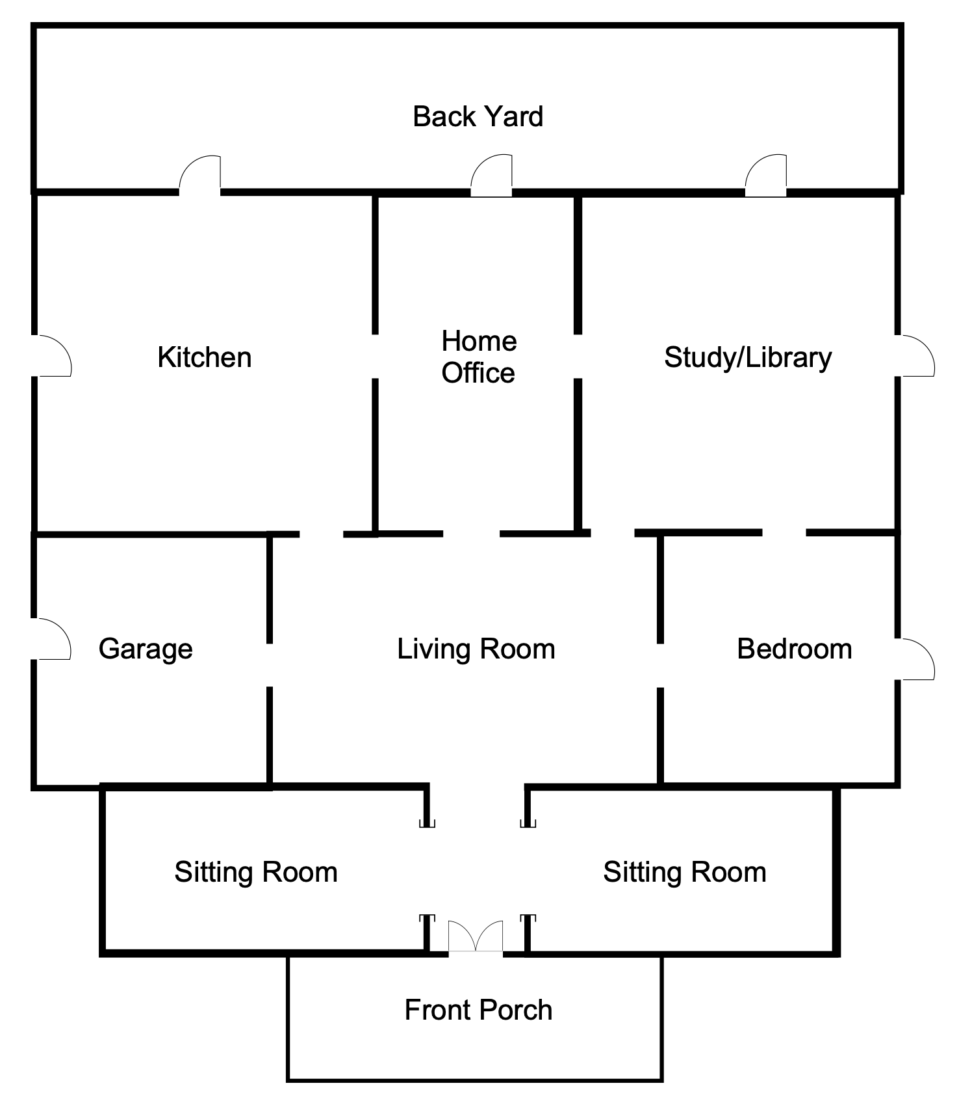
The Church House floor plan, reproduced from Pastoral Ministry: Systems, Processes, and Resources (2024)

The rooms

Front Porch — Evangelism
The front porch is where we meet first-time guests and regular visitors. It is the advertising we do in the community and online. It is the welcome desk. It is the way we invite people to church, and it is often the first thing people see when they encounter our church.

Vestibule, the Sitting Room — Fellowship
Unlike your grandmother’s house, in this sitting room you are encouraged to recline on the couches and make yourself comfortable. Fellowship is an important part of the Christian community. It gives us a place to build friendships without programmatic expectations or discipleship pre-work. Supper clubs, affinity groups, and potlucks are all examples of fellowship ministries.

Living Room — Worship
Almost every other room in this house has a doorway into and out of the living room. The living room is the center of the house, just as worship is the lifeblood and center of our Christian faith. Everything we do flows out of and back into worship.

Bedroom — Prayer
Jesus said when you pray, you should go into your room and close the door. The bedroom is the most personal and intimate space in the house, just as prayer is the most intimate place we meet with God.

Kitchen — Service and Outreach
Service and outreach are the mission and calling of the church. We do not exist for ourselves but for others. The kitchen is where we prepare the physical and spiritual food that feeds the world. As the old line has it, the church is not a museum for the saints but a hospital for sinners.

Garage — Operations
There is a lot of behind-the-scenes work that goes on at the church. Our operations staff and volunteers are essential for the church house to thrive. Like the garage that stores our tools is often an unappreciated space in the house, so too the operations of our church sometimes fail to receive the credit they deserve for helping the Church do its Gospel work.

Library and Study — Discipleship
To know is to grow. Discipleship and education are necessary for Christian sanctification. We grow closer to Christ when we know more about Christ. The library and study is the place where we can explore the nature of faith and grow deeper in our walk. These ministries include Bible studies, youth groups, children’s ministry, Sunday School, small groups, and short-term classes.

Back Yard — High Energy Events
We believe the Church should have fun. High-energy events like Vacation Bible School, dinner on the grounds, pumpkin patches, and retreats are great ways to engage new people in the life of the church. They also provide an opportunity for people to gather who might not have other places to run into each other.

Home Office — Administration
To maintain all the wonderful ministries, missions, and programs, the church requires order and management. The administration of a church is necessary to ensure we are good stewards of God’s gifts and use all God has given in the best ways possible.

How to use it
- As a map of the whole. List your congregation’s ministries and place each one in a room. The exercise alone usually reveals a crowded room or two and a room nobody has entered in years.
- To check the front door against the rest of the house. A church can pour everything into the front porch and have no library or kitchen to welcome people into. Growth that has nowhere to land does not last.
- To value the unglamorous rooms. The garage and home office rarely get applause, but the house does not function without them. Naming them as rooms helps a congregation honor the people who keep them.
- In planning and staffing. When a room is consistently dark, that is a discernment prompt: is this a season to light it, or to accept that another church in the area carries that ministry better?

